Feasibility of Pulling Screens at MCN to assist with Juvenile Lamprey Outmigration

The 2008 Action Agency-Tribal Accord specifies actions needed to be undertaken and considered to assist with Pacific Lamprey Passage. Item #3 under juvenile actions to be taken says the COE shall, “consider lifting extended length screens (primarily at McNary but also at Columbia and Snake River dams) in consultation with the NOAA and the Tribes.” It is recognized that juvenile lamprey has impingement and mortality issues related to coming in contact with the extended screens that do not have the new juvenile lamprey gap criteria installed, that an undetermined % but often large numbers of the outmigrating juvenile lamprey come in contact with these screens, that turbine passage is considered a safer route for juvenile lamprey passage based on simulated pressure spike laboratory turbine passage studies, and that in 2009 the outmigration of the juveniles from the last large adult Pacific lamprey upstream migration will occur.

This action was discussed at fall 2008 FFDRWG and FPOM meetings and it was decided that before any decision regarding pulling extended screens at MCN could be made that the data on juvenile and smolt passage timing, the potential effect on project survival of outmigrating yearling Chinook and steelhead, the logisitics of pulling and replacing screens, and other passage parameters needed to be summarized and reviewed. This document is a first step of examining some of these data.

Juvenile Lamprey Passage at Powerhouses

The USACE conducted studies on downstream juvenile Pacific lamprey passage from 2000 to 2002. Based on fyke net evaluations of run-of-the-river fish at John Day, McNary, Bonneville, and others, the majority (> 70%) juvenile lamprey move downstream low in the water column under the turbine intake screens of bypass systems installed for salmonids at USACE dams (BioAnalysts Inc. 2000; Moursund et al., 2003; Monk et al., 2004; Moursund et al., 2006). See the other attached document for additional details of fyke net evaluations of juvenile lamprey passage at powerhouses. This results in the majority of juvenile lamprey tending to pass the dams through the turbines when they encounter a powerhouse. Laboratory studies by Pacific Northwest National Laboratory demonstrated that juvenile lamprey are much less likely than salmon to be harmed by changes in pressure and shear conditions that occur during turbine passage, and that turbine passage may be a relatively safe route.

Logistics of screen removal and replacement

To remove or replace all screens at MCN routinely takes about one week, making rapid responses to upstream numbers of downstream moving fish very difficult.

Effects on survival of Chinook and Steelhead with MCN screens removed

By examining the passage route specific data (route distribution and survival rates) for the 2006 and 2007 studies cited below and altering proportions by assuming all JBS fish would be passing via the turbines without the screens, the relative change on survival of Chinook and steelhead was estimated (Tables 1 and 2).

2006
Adams, N.S., J.M. Plumb, T.W. Hatton, E.C. Jones, N. M. Swyers, M. D. Sholtis, R.E. Reagan, and K.M. Cash. 2008. Survival and migration behavior of juvenile salmonids at McNary Dam, 2006 Draft Report of Research by the U.S. Geological Survey to the U. S. Army Corps of Engineers, Walla Walla District, Report number 2006-W68SBV60478899, Walla Walla, Washington.

2007
Adams, N.S. and T.D. Counihan, editors. 2008. Survival and migration behavior of juvenile salmonids at McNary Dam, 2007. Draft Report of Research by the U.S. Geological Survey to the U.S. Army Corps of Engineers, Walla Walla District, Contract W68SBV70178419, Walla Walla, Washington.

Table 1. Estimated change in dam passage survival of yearling Chinook salmon and steelhead passing McNary Dam with and without fish guidance screens based on the 2007 survival study draft results.

 | Yearling Chinook  (paired release) |  |  | Juvenile Steelhead  (single release)
Passage Route
 | Survival | Passage |  | Survival | Passage
Turbine | 0.833 | 0.143 |  | 0.678 | 0.045
Bypass | 0.923 | 0.287 |  | 0.861 | 0.172
Spillway | 0.967 | 0.319 |  | 0.900 | 0.127
TSW2 | 0.931 | 0.078 |  | 0.969 | 0.182
TSW1 | 0.944 | 0.173 |  | 0.908 | 0.475
Dam Survival w/Screens | 0.928 |  |  | 0.901
Dam Survival w/o Screens | 0.903 |  |  | 0.869
Percent Change | 2.8% |  |  | 3.5%

Table 2. Estimated change in dam passage survival of yearling Chinook salmon and steelhead passing McNary Dam with and without fish guidance screens based on the 2006 survival study draft results.

 | Yearling Chinook  (paired release) |  |  | Juvenile Steelhead  (single release)
Passage Route
 | Survival | Passage |  | Survival | Passage
Turbine | 0.851 | 0.125 |  | 0.855 | 0.102
Bypass | 0.968 | 0.240 |  | 0.980 | 0.250
Spillbays 1-15 | 0.969 | 0.385 |  | 0.989 | 0.366
Spillbays 16-22 | 0.991 | 0.250 |  | 0.978 | 0.282
Dam Survival w/Screens | 0.960 |  |  | 0.970
Dam Survival w/o Screens | 0.931 |  |  | 0.939
Percent Change | 2.9% |  |  | 3.2%

Passage Timing of Juvenile Lamprey, Spring Chinook yearlings and steelhead

Below are graphs of multiple years of juvenile lamprey, yearling spring Chinook, and steelhead passage timing at MCN taken from the FPC website (97-07) to examine the overlap of passage timing as part of the evaluation of the feasibility of lifting screens to minimize negative effects to lamprey during downstream passage.
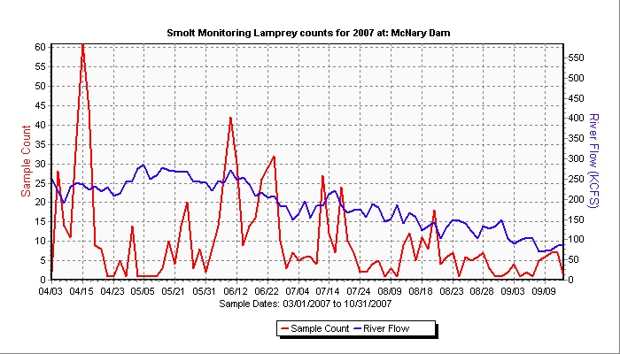
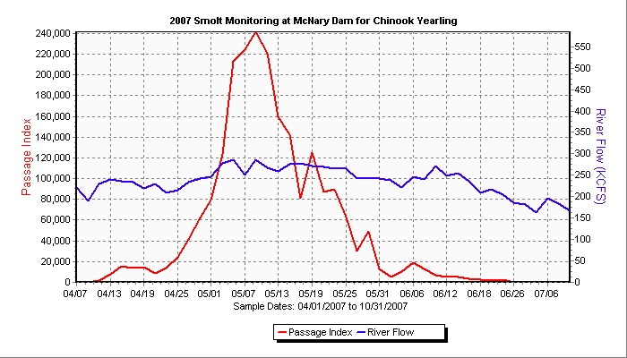
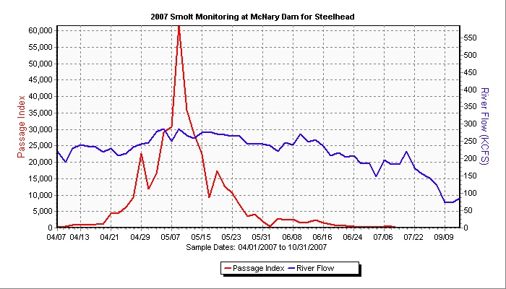
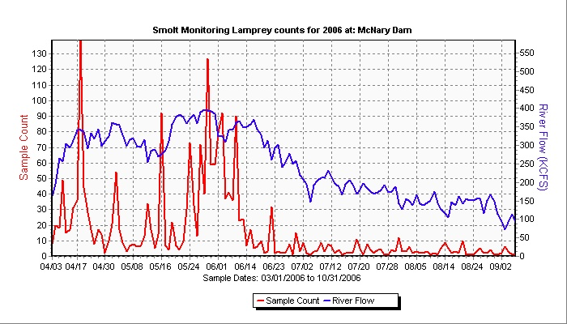
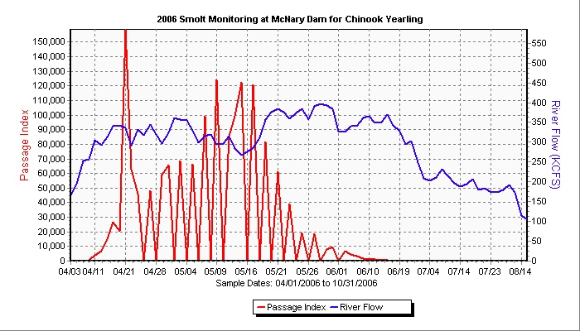
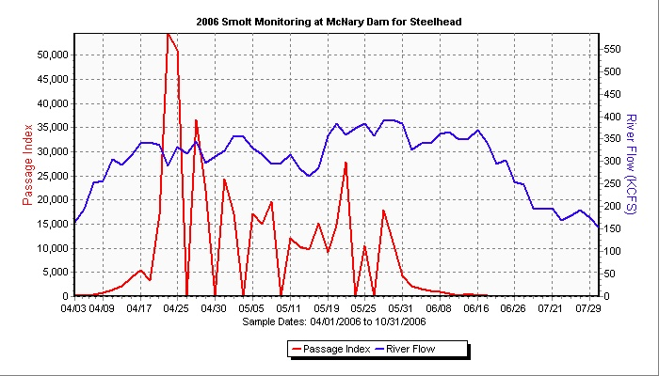
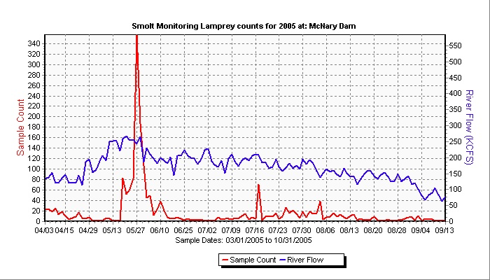
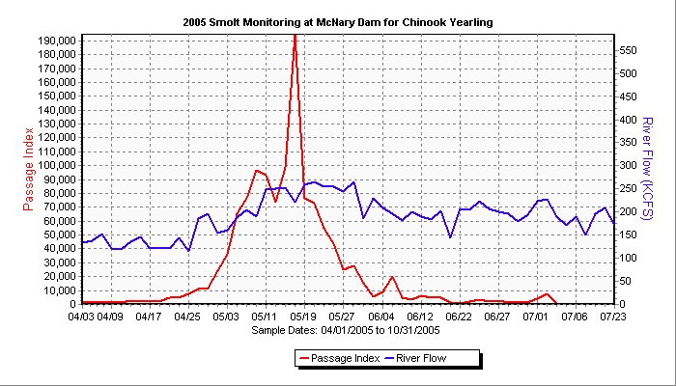
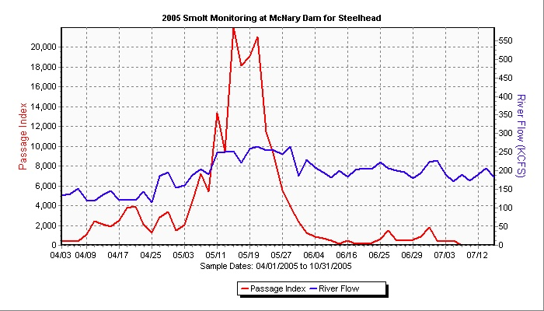
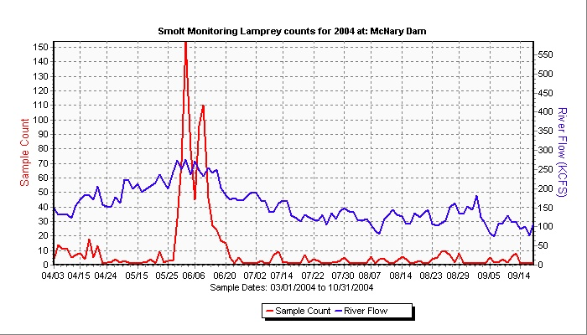
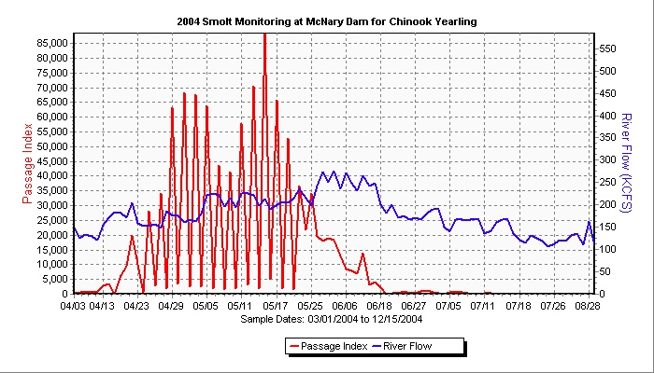
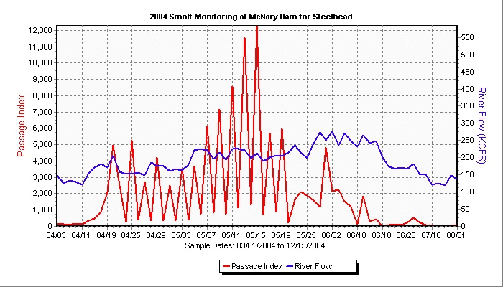
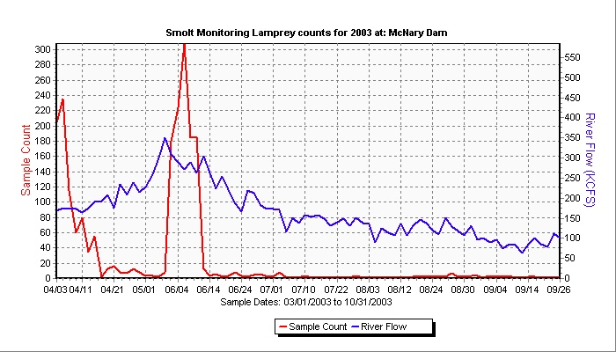
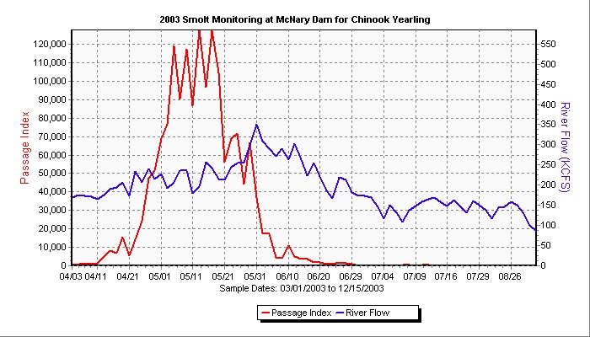
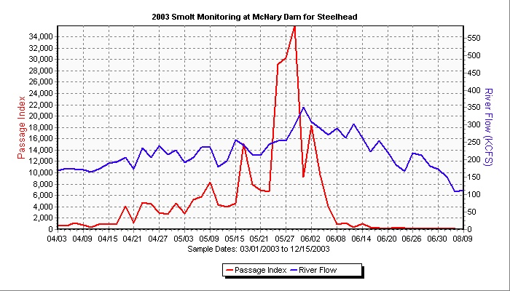
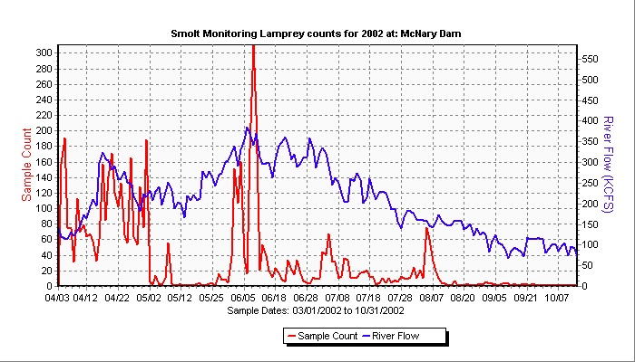
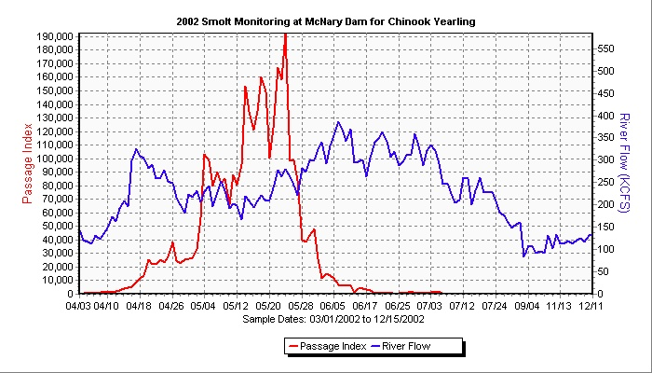
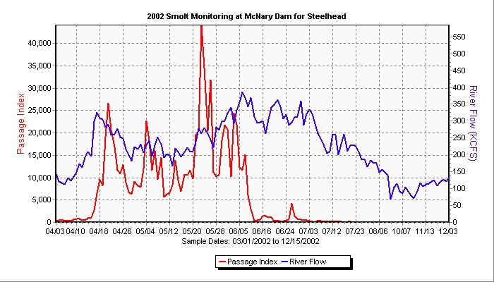
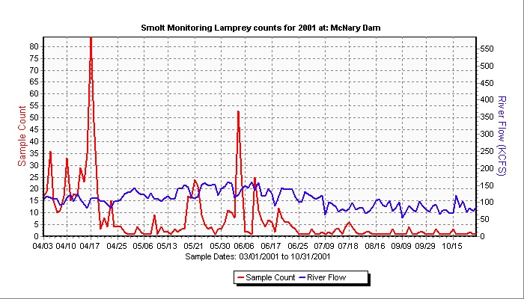
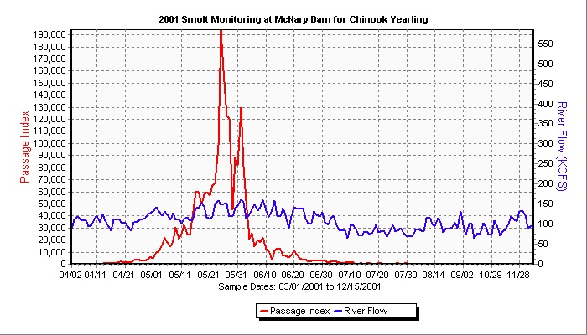
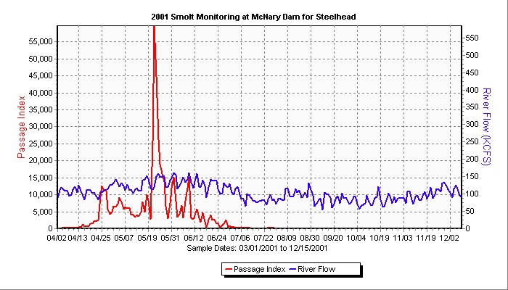
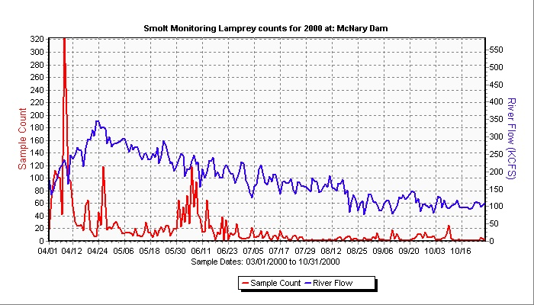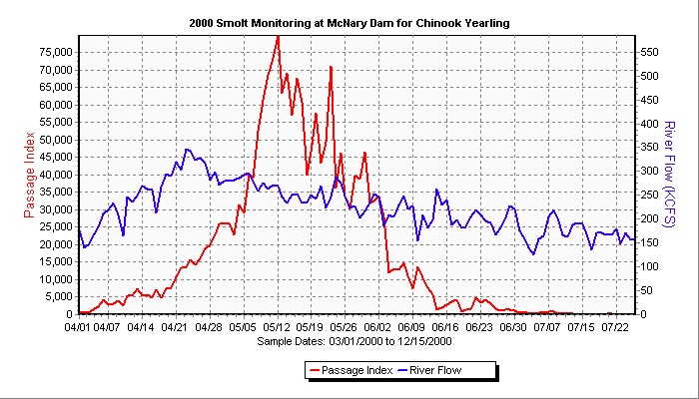
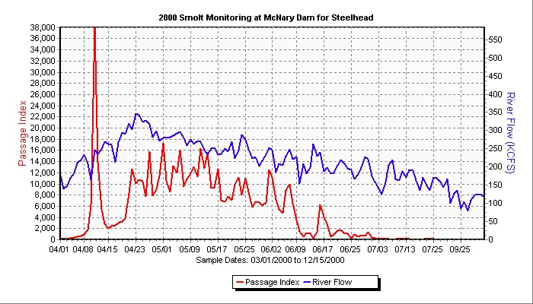
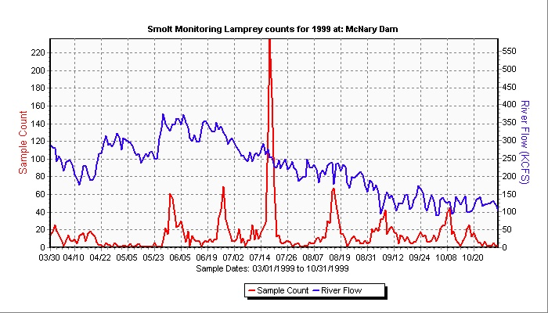
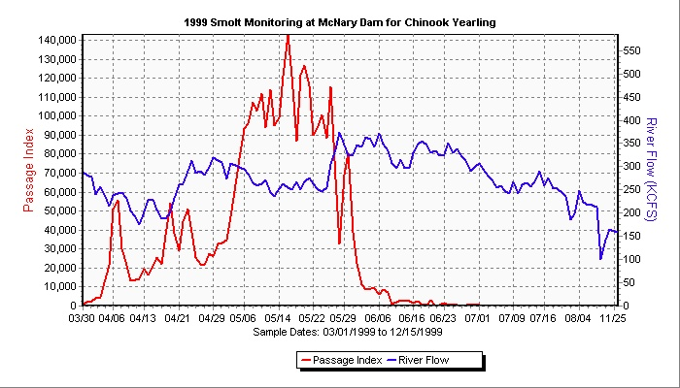
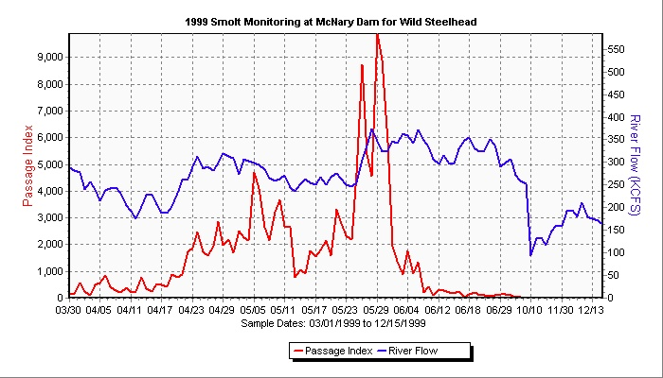
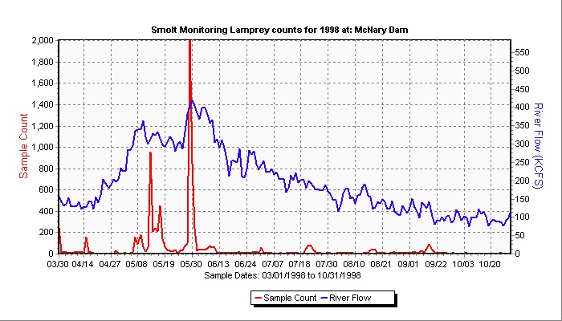
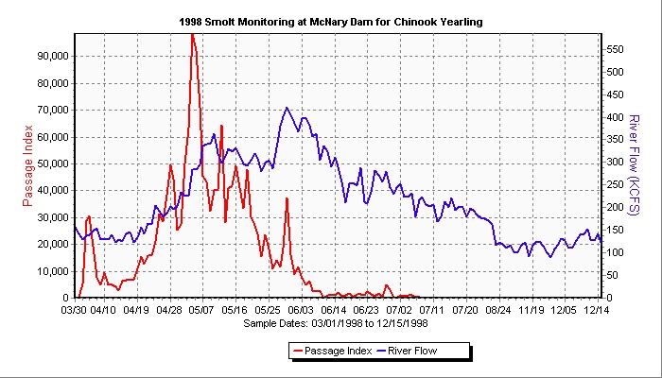
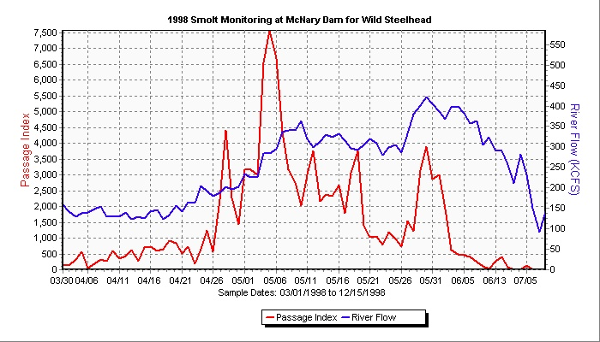
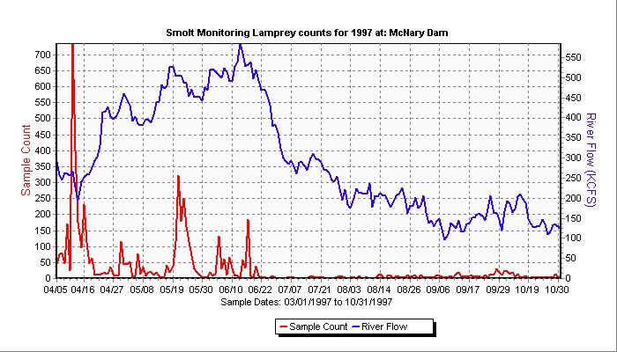
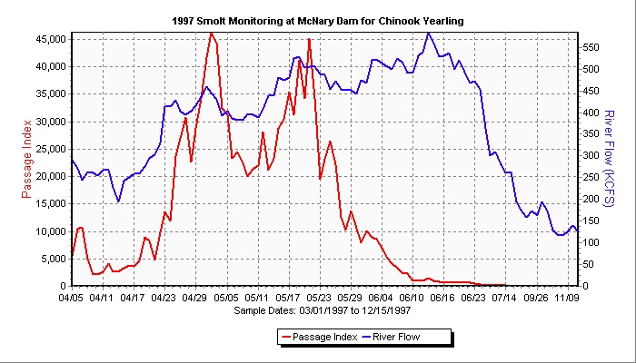
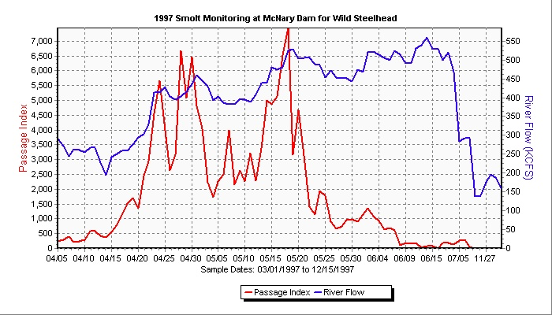

There is considerable overlap in the peak of passage for these three species allowing very little opportunity to remove and reinstall screens considering the time it takes to perform these operations. However, during all but 3 of these 11 years of data, postponing installation of screens until Apr 7-10 would have kept an early bump in juvenile lamprey passage off the screens and made them pass through the turbines. Only during 3 of the 4 earliest years (97, 98, and 2000) was there a small early bump of either steelhead or Sp Chinook that would have been affected.

Considering the time and resources needed to install and remove screens at MCN and the potential impacts to ESA listed juveniles during outmigration, the only potential action that can be taken is to postpone installation of the screens a week to 10 days.

